**PEANUT BUTTER & JELLY SANDWICH DOCUMENTATION**

**Version History**

|  |  |  |  |
| --- | --- | --- | --- |
| **Version** | **Date** | **Name** | **Description** |
| **1.1** | **10/24/2018** | **Krishna Nambi** | **Initial Preparation Document** |

**Introduction**

The American classic peanut butter sandwich is a famous and tasty American staple and is affectionately called as the PB&J sandwich. The PB&J makes for a quick and easy lunch or snack due to the less amount of time and ingredients required in making the sandwich. The Peanut Butter and Jelly sandwich consists of one or two slices of bread with layers of peanut bread and jelly spread between the slices of bread. The following document intends to provide step by step instruction on the ways to create the classic peanut butter and jelly sandwich.

**Resources**

In order to prepare the sandwich, we would require the following items:

* Slices of bread
* Peanut butter spread
* Jelly spread

**Process Steps**

Setup: Identify and assemble the resources required for making the sandwich such as the bread to be used (usually one or two slices per sandwich), peanut butter spread, jelly spread and a butter knife for spreading the ingredients.

1. Place the bread slices on the prep table. You can either prepare a single slice PB&J sandwich or a double sliced sandwich as per preference.

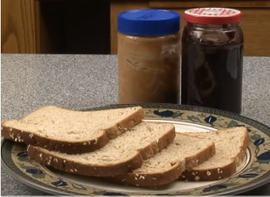

1. Use the knife to spread a generous layer of peanut butter on one slice of the bread.

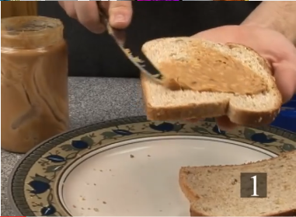

1. Now use the knife to spread the jelly on the other slice of bread. You can alter the amount of jelly or peanut butter spread on the slice as per preference.

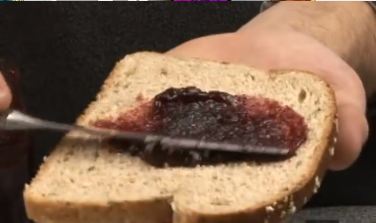

1. Place the slices of bread together with the jelly and the peanut butter side facing one another.

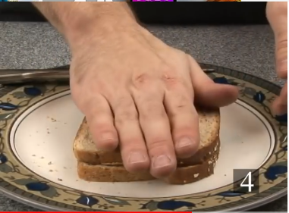

1. Cut the sandwich in a triangular half or rectangular half shapes for easier eating.

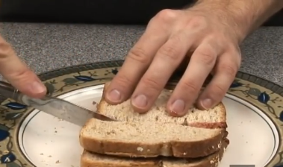

1. Your Peanut butter and Jelly sandwich is ready for eating. In case of a single slice of PB&J sandwich, spread the peanut butter and jelly on one side of the slice and fold the layered side into a rectangular half for a quick and easy bite.

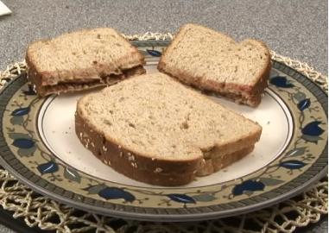

**Tips and Suggestions**

* While using the peanut butter spread right from the refrigerator, allow the jar to set to normal room temperature for better spread and taste.
* PB & J sandwiches are best served when grilled for better taste and flavor.
* The sandwich preparation method can also be altered by adding extra ingredients such as strawberries and different types of jelly spreads.

**Process flow diagram**

The following diagram represents the peanut butter and jelly sandwich preparation steps.

Place the bread slices on the prep table

The single slice PB&J sandwich is ready to eat

Fold the layered side of the bread slice into a rectangular half

Apply Jelly spread on top of the peanut butter layer on the bread slice

Apply peanut butter on one side of the bread slice

Single slice PB&J or double slice sandwich?

Apply peanut butter on one side of the bread slice

Apply Jelly on the other slice of bread

Place the two slices together with jelly and peanut butter sides facing one another

Cut the sandwich in half and its ready to eat.

Single slice sandwich

Double slice sandwich

Word Count: 518